# Program Overview: This program generates the calculated average MPG of a car and the total amount of money spent on fuel.

## Main GUI Screen Layout Diagram:

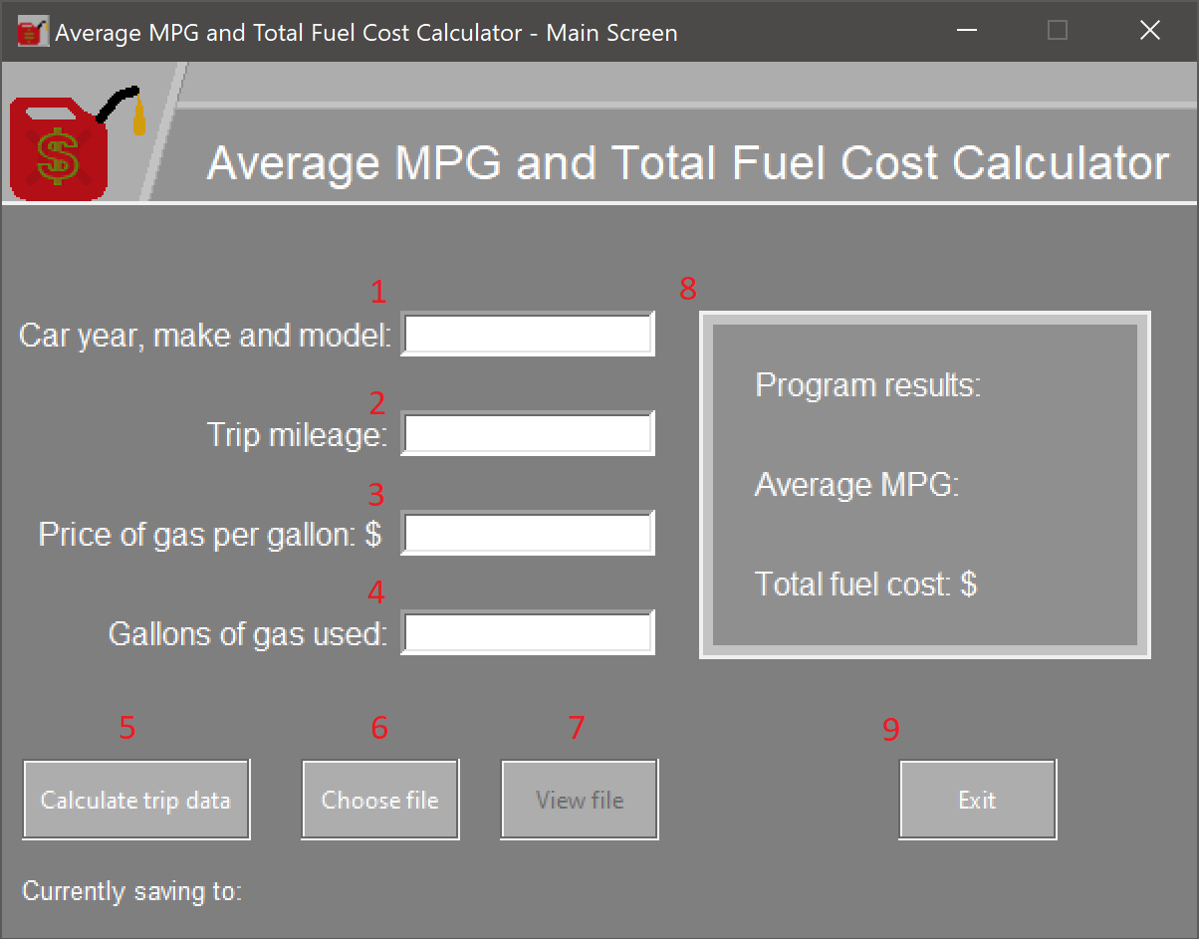

# Explanation of the above information diagram:

1. This is where a user enters the demographics of their car to personalize the results written to a file
2. Users enter the length of a trip in miles to be used to calculate fuel economy data.
3. Users enter the current price of gas at the time of the trip to determine how much money was spent on that trip.
4. Users enter the amount of gas they used to be used in the calculate the average MPG.
5. **Calculate trip data.** This button processes the information entered and calculates the fuel economy for the current car.
6. **Choose File.** Once all the input fields have been filled in**,** this button allows a user to choose a new file to write data to.
7. **View File.** This opens the current file path for viewing the written data contained inside.

Mathematical formulas that this program uses:

To calculate average Mpg, it divides your trip mileage by the gallons of gas that were used.

To calculate the total fuel cost, it divides your trip mileage by the calculated average MPG.

1. **Program results panel.** This is where the fuel economy results are displayed follow a successful run of the program.

Below is an example of successful program output:

The prompt is asking whether the user would like to create a file to save the calculated data to or not.

1. Exit. This button opens the ‘Are you sure?’ prompt to make sure the user wants to exit the program. This prompt prevents a user from accidently exiting the program.

Below is a valid set of datapoints in each input field. To calculate fuel economy for these parameters click on ‘ Calculate trip data.

Afterwards, it asks the user if they would like to save the fuel economy data to a file.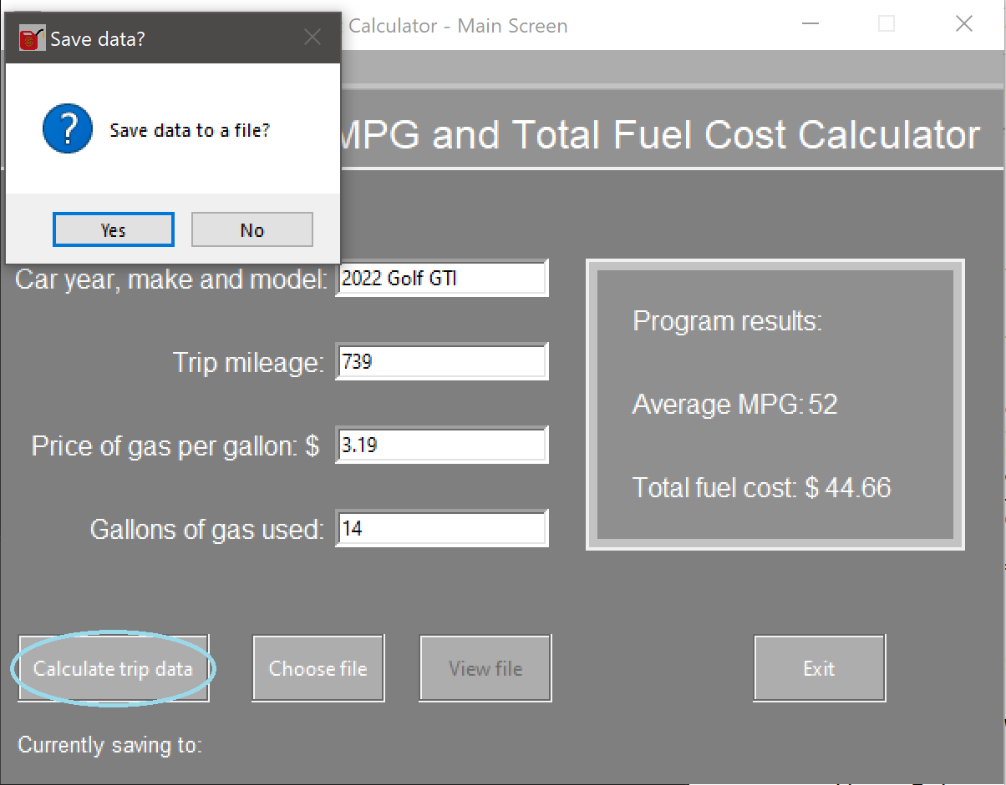

Once a user clicks ‘Yes’ on the save data to a file prompt, this file explorer pops up.

On this window, you can select a file location to save fuel economy data to. The program already constructs a suggested filename for the user based on the car demographics that were entered.

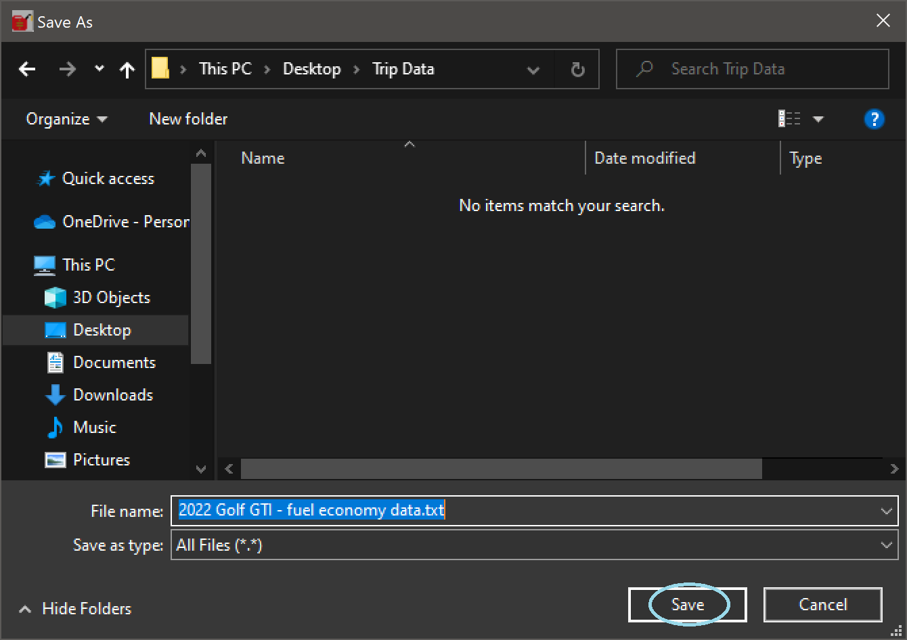

On this window go ahead and click on save once you have chosen a desired name and file path.

Once a user clicks on the ‘save’ button on the file explorer screen, the program asks the user if they would like to write the calculated fuel economy data to a file. Users are free to choose whichever option they want.

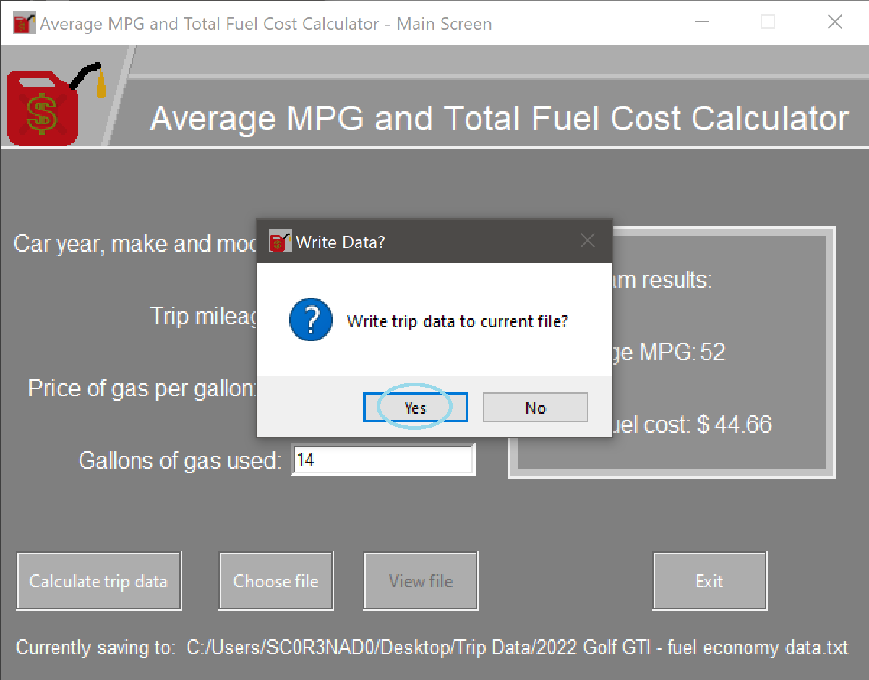

If the user responds ‘Yes’ to this prompt, the program clears out all input fields to make room

for another set of datapoints to be entered.

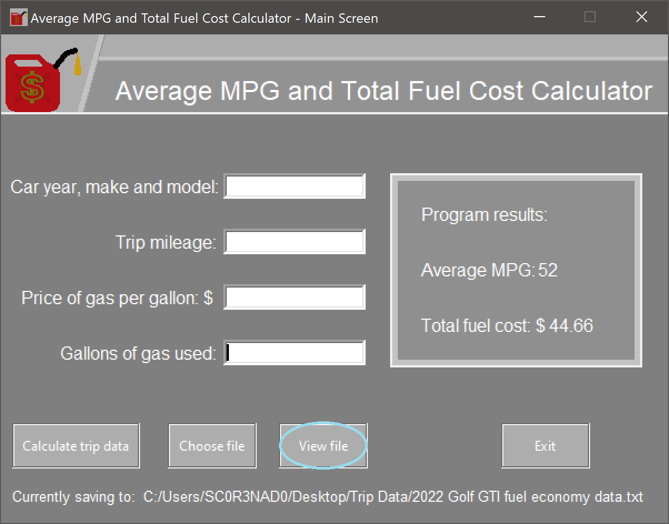

Once a valid file path has been selected, the ‘View File button is enabled, and the user can view the written results of the program. But if they would rather audit the results, they can still see the data in real-time on the program results panel.

This is the ‘View File’ screen. Here you can view the data that was written to your chosen file.

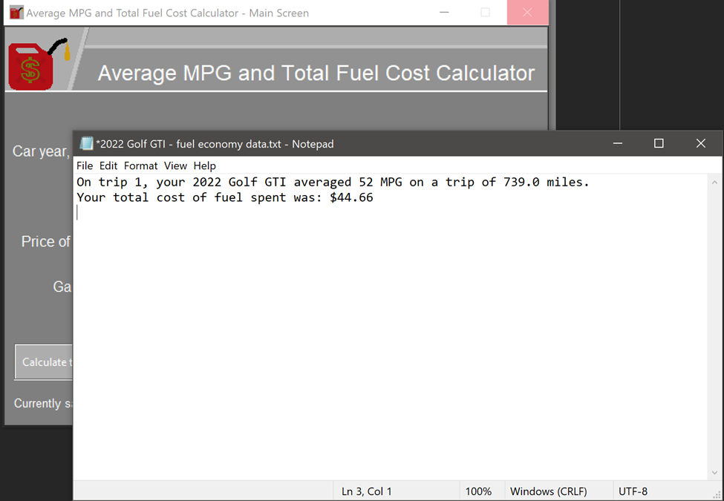

Be sure to close the open file window before returning to the main GUI because if left open, it can cause the program to say ‘Not responding and freeze temporarily.’ If that starts to occur, close the open ‘View File’ screen and it will start responding again immediately.

Once the ‘View File screen is closed, the user can perform any of the actions in this manual again or if you are finished calculating data, the User can exit the program with ease.

# Error FAQ:

**Missing input field entries**

**Reason:** This error is caused by failing to fill all the input fields with input.

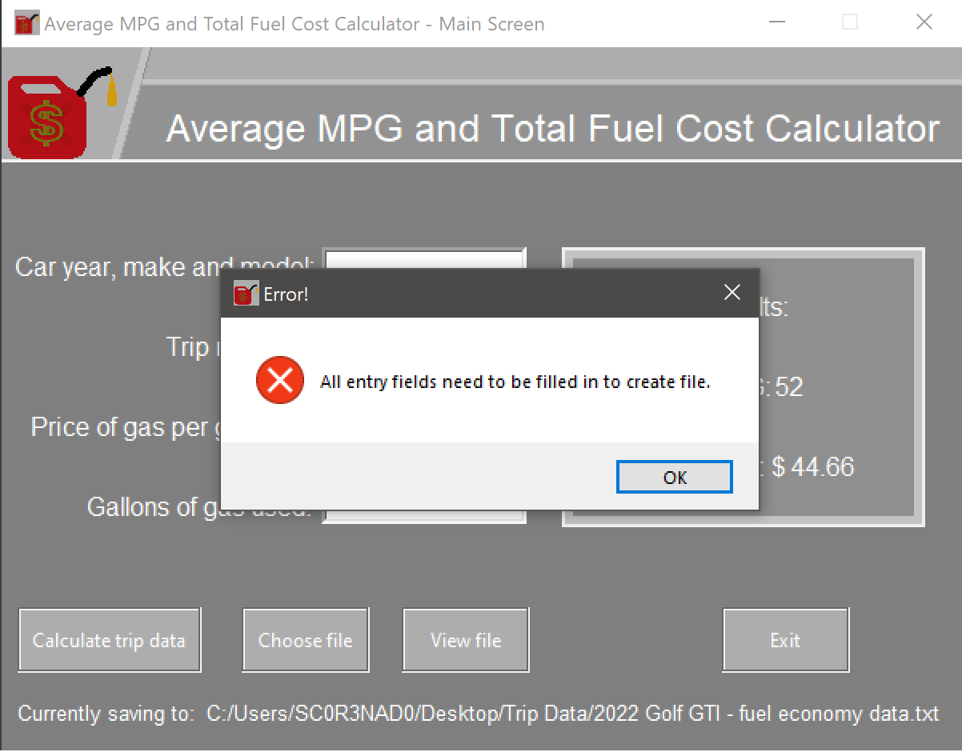

**Invalid car demographics**

**Reason:** This error is caused by typing in erroneous car demographics such as one without a year and make.

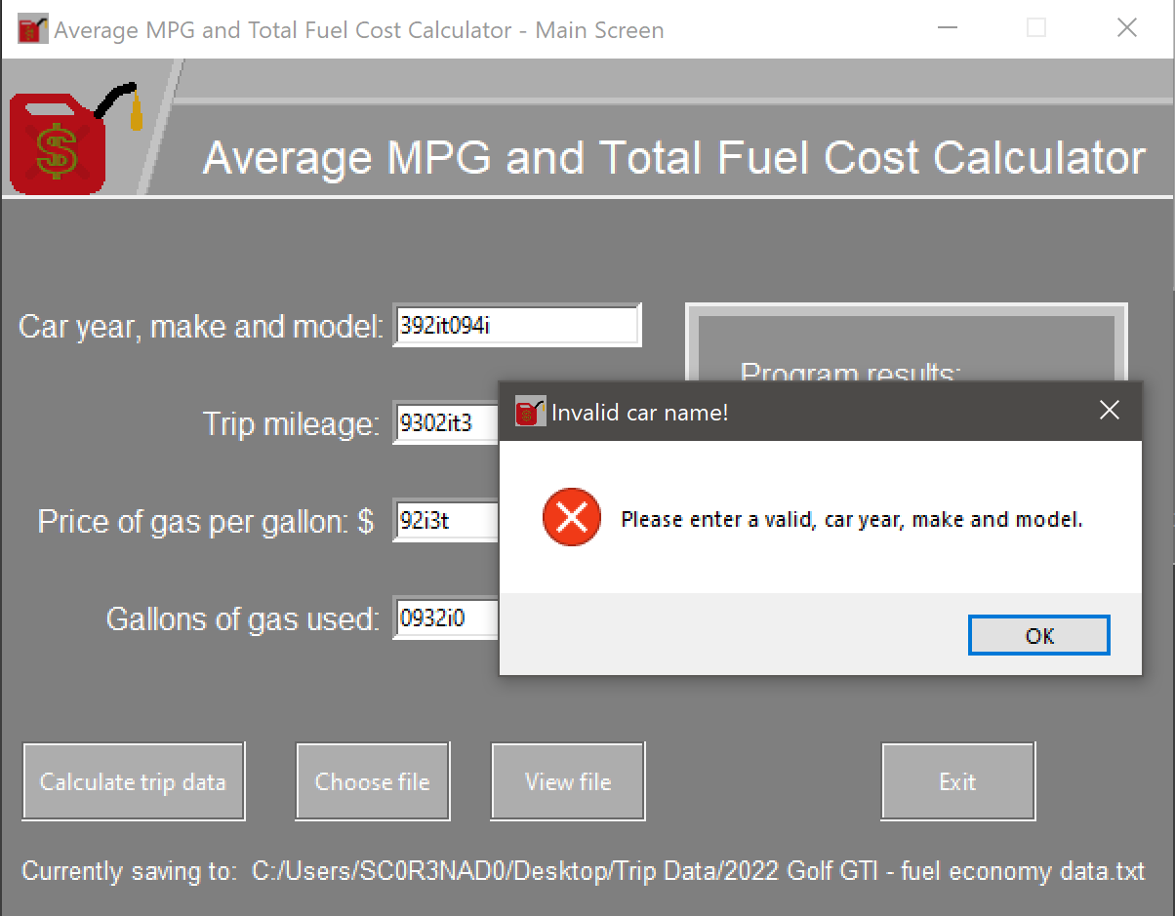

**Numerical entry field contains string input**

**Reason:** A user typed in either a number less than or equal to zero, or one that contains illegal characters such as letters or special characters.

